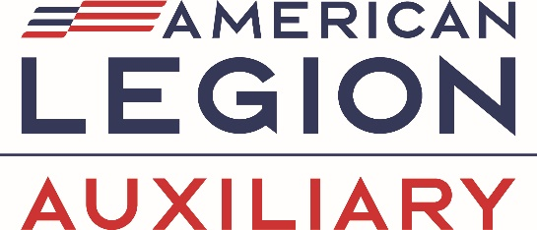AMERICAN LEGION AUXILIARY

DEPARTMENT FUNDRAISER



CHANCE TO

WIN A PUFL

MEMBERSHIP

1 Chance $20

2 chances $25

3 chances $35

PUFL membership can be used for yourself or gifted to someone else within 30 days

The proceeds from this fundraiser will go toward the Department of Missouri expenses for responsibilities at the 2027 National Convention in Kansas City, Missouri.

The drawing will take place at the 2025 Department Convention. You do not need to be present to win.

Return this portion with check made payable to

ALA Department of Missouri

Official Rules

1. Each form must be filled out and returned with cost of chances.
2. Each ticket must be returned to ALA 600 Ellis Blvd, Jefferson City, MO 65101
3. It is the responsibility of the purchaser to notify the department of any address change.

Name _________________________ Unit ____ District ___

Please print

Address ________________________________________

City ______________________State ______ Zip ________

Phone # ____________________

Number of Chances ________ Total amount included $______